Bahagian A
[10 markah ]
[ Masa dicadangkan : 15 minit ]

Gambar di bawah menunjukkan langkah-langkah keluarga yang bahagia.
Tulis lima ayat yang lengkap tentang langkah-langkah membentuk keluarga yang bahagia berdasarkan gambar.

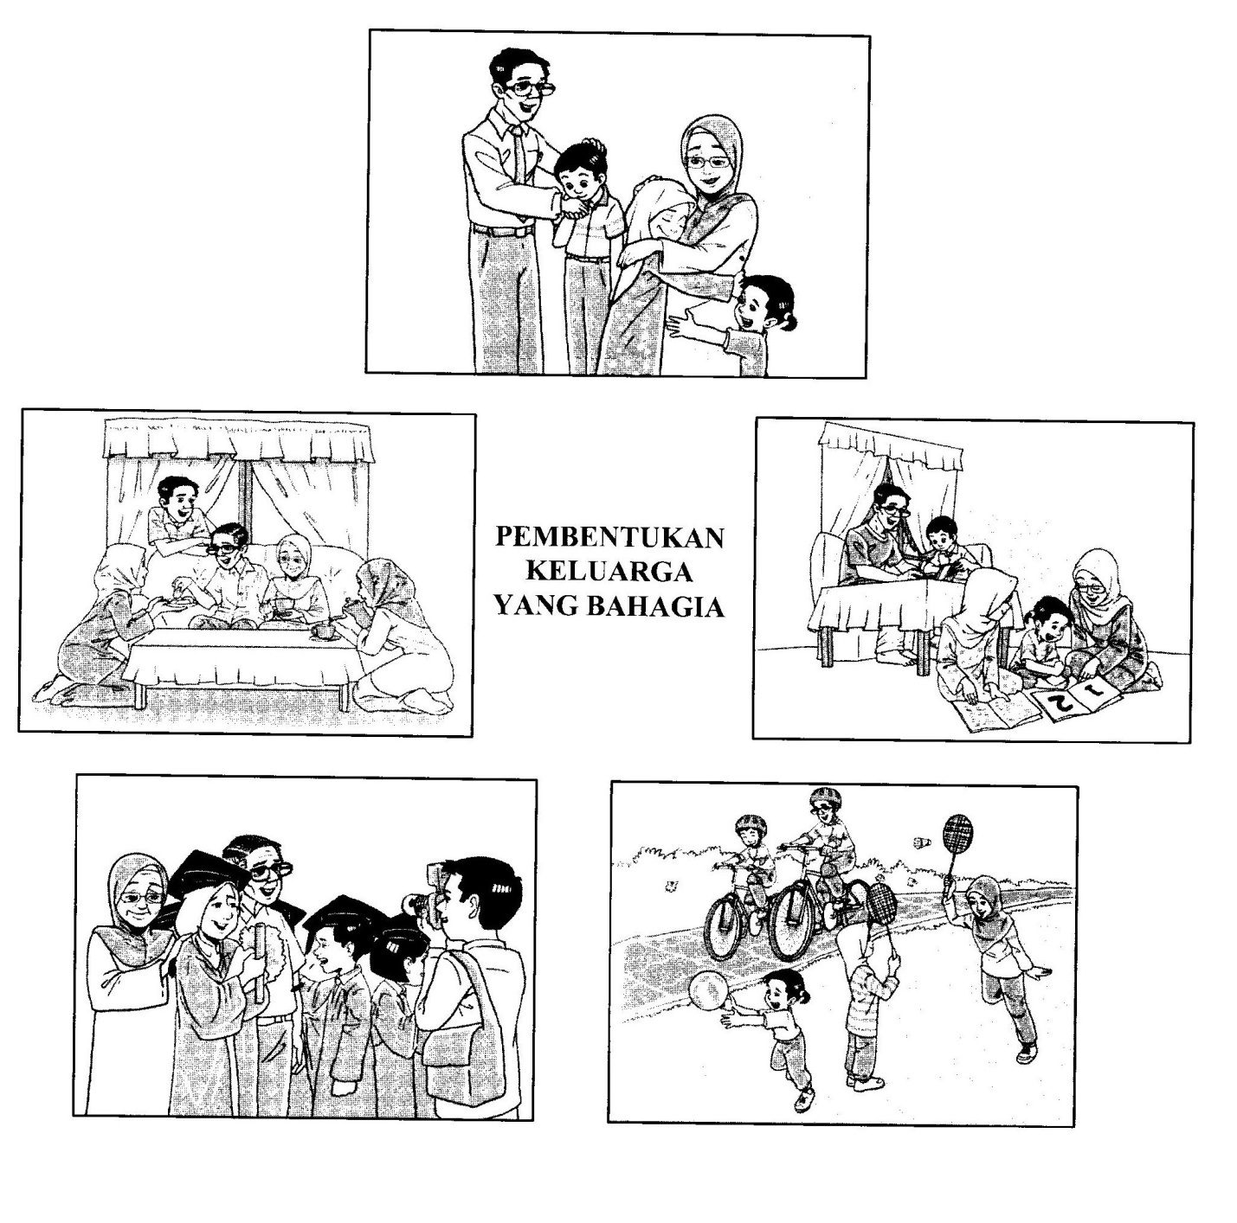
[Lihat halaman sebelah
Bahagian A

__________________________________________________________________________________________________________________________________________________________________________________________________________________________________________________________________________________________________________________________________________________________________________________________________________________________________________________________________________________________________________________________________________________________________________________________________________________________________________________________________________________________________________________________________________________________________________________________________________________________________________________________________________________________________________________________________________________________________________________________________________________________________________________________________________________________________________________________________________________________________________________________________________________________________________________________________________________________________________________________________________________________________________________________________________________________________________
10

[ Lihathalamansebelah
Bahagian B
( 15markah )
( Masa yang dicadangkan : 25 minit )

Gambar dibawah ini menunjukkan poster pyramid makanan.
Tulis ulasan tentang piramid makanan tersebut dalam bentuk perenggan.
Panjangnya ulasan kamu hendaklah antara 50 hingga 80 patah perkataan.

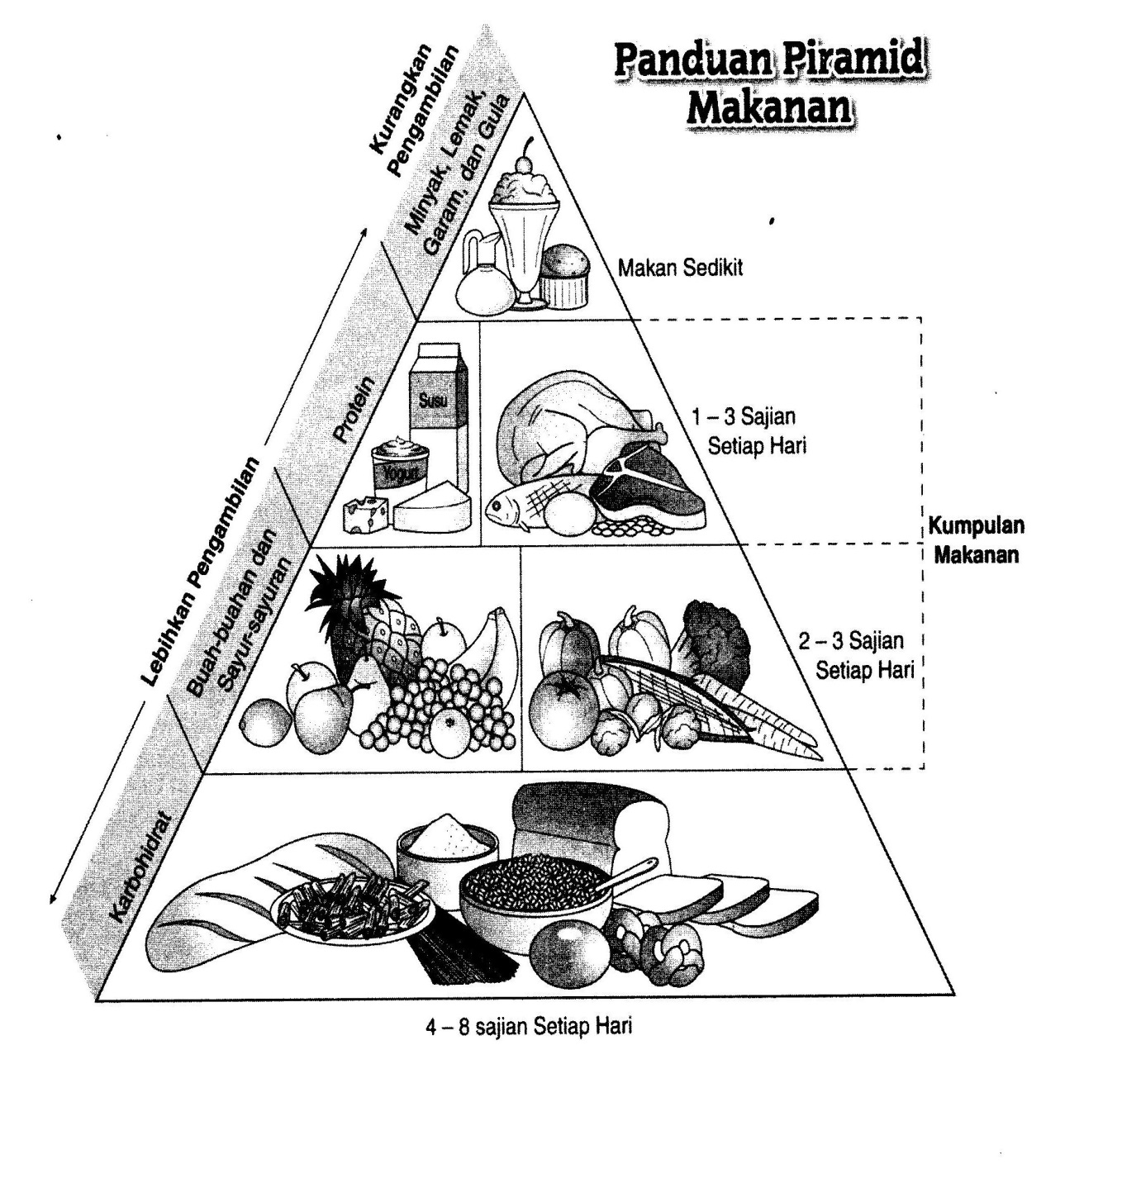

[ Lihat halaman sebelah

Bahagian B
________________________________________________________________________________________________________________________________________________________________________________________________________________________________________________________________________________________________________________________________________________________________________________________________________________________________________________________________________________________________________________________________________________________________________________________________________________________________________________________________________________________________________________________________________________________________________________________________________________________________________________________________________________________________________________________________________________________________________________________________________________________________________________________________________________________________________________________________________________________________________________________________________________________________________________________________________________________
15

[ Lihat halaman sebelah

Bahagian C
( 25markah )
( Masa yang dicadangkan : 35 minit )

Bahagian ini mengandungi dua soalan.Jawab satu soalan sahaja.
Panjangnya jawapan kamu hendaklah antara 80 hingga 120 patah perkataan.

Soalan 1
Kawan baik kamu tidak datang ke sekolah. Kamu telah menelefonnya untuk mengetahui sebabnya.Tulis perbualan antara kamu dengan kawan kamu itu.

ATAU
Soalan 2
Bangsa Malaysia berhemah tinggi
Ramah dan mesra elok pekerti
Yang tiada dibantu, yang lemah dilindungi
Bertimbang rasa hormat menghormati

Kita berkhidmatjujur dan ikhlas
Mencurah bakti tak minta dibalas
Harapan rakyat satu amanah
Budi Bahasa budaya kita

Dua rangkap di atas merupakan korus lirik lagu “Budi Bahasa Budaya Kita” yang dinyanyikan oleh Datuk Siti Nurhaliza.Lirik tersebut menggambarkan pentingnya budibahasa demi memperkasa budaya bangsa.

Berdasarkan maksud lirik lagu tersebut.Tulis cerita berpandukan situasi yang diberi.

Kamu dan kawan-kawan kamu sedang menunggu bas. Tiba-tiba kamu ternampak seorang warga emas terjatuh di atas jalanraya. Semua barang yang dibawanya bertaburan.

Ceritakan tindakan yang kamu ambil untuk membantunya.

[Lihat halaman sebelah

No. Soalan

___________________________________________________________________________________________________________________________________________________________________________________________________________________________________________________________________________________________________________________________________________________________________________________________________________________________________________________________________________________________________________________________________________________________________________________________________________________________________________________________________________________________________________________________________________________________________________________________________________________________________________________________________________________________________________________________________________________________________________________________________________________________________________________________________________________________________________________________________________________________________________________________________________________________________________________________________________________________________________________________________________________
[Lihat halaman sebelah
________________________________________________________________________________________________________________________________________________________________________________________________________________________________________________________________________________________________________________________________________________________________________________________________________________________________________________________________________________________________________________________________________________________________________________________________________________________________________________________________________________________________________________________________________________________________________________________________________________________________________________________________________________________________________________________________________________________________________________________________________________________________________________________________________________________________________________________________________________________________________________________________________________________________________________________________________________________________________________________________________________________________________________________________________________________________________________________________________________________________________________________________________________________________________________________________________________________________________________________________________________________________________________________________________________________________________________________________________________________________________________________________________________________________________________________________________________________________________________________________________________________________________________________________________________________________________________________________________________________________________________________________________________________________________________________________________
25
KERTAS SOALAN TAMAT

